**18MIS0159**

**Kamisetty Hrutheesh Kumar Guptha**

**Bungee Coding Round**

**Problem Statement:-**

You are provided with a file "main.csv" in the input folder for each question. You need to upload the solution code file and the solution output csv file to respective answer folder in the output folder

1. g. if you are answering question-1 and consider input file as /input/question-1/main.csv and upload the file output csv file to /output/answer-1/main.csv and solution code file also to the same folder

if you are answering question-3 and consider input file as /input/question-3/main.csv and upload the file output csv file to /output/answer-3/main.csv and solution code file also to the same folder

Question-1. Consider input file as /input/question-1/main.csv and give the output to /output/answer-1/main.csv and upload solution code file also to the same folder.

The price column contains some missing values. How can we replace these missing values with the average price of the product? Please note that we should not fill the missing values with the average value of the price column. The missing values for apples need to be filled with the average price of apples, and so on.

**Expected output:- will be the columns with filled data.**

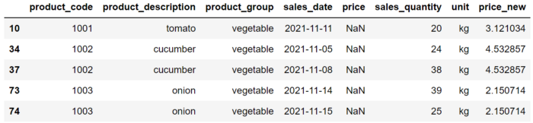

Question-2. Consider input file as /input/question-2/main.csv and give the output to /output/answer-2/main.csv and upload solution code file also to the same folder.How can we create a sales amount column that shows how much product in kg is sold in each sale.

The unit for some products is kg so we can just take the value in the sales quantity column for them. However, some of the products are sold in pieces. The weight information for these products can be extracted from the description.

**Expected output:- will be added sales amount**

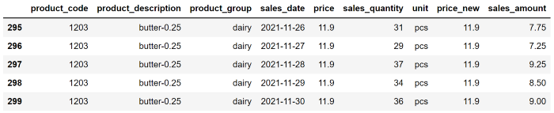

Question-3. Consider input file as /input/question-3/main.csv and give the output to /output/answer-3/main.csv and upload solution code file also to the same folder. Sort the teams by Red Cards, then to Yellow Cards

**Expected output:-will be the sorted cards.**

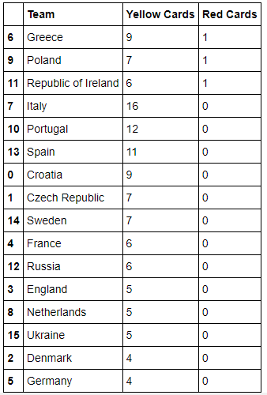

Question 4:- How would you rate the difficult of the assessment on a scale of 1 to 10, 1 being very simple and 10 being very hard?

**10**

Do you want another assessment which more focused on Data structures and algorithms?

**NO**

Please answer this question in the email itself which you are going to send to submit the link of the assessment github repo.

**Submission guidelines:-**

1. You are free to use any coding language.(Don’t use sql or excel to solve the problem or you will be instantly disqualified )
2. Mention the details that are required to run the code in Github readme file.
3. Fork this repo or create a new Github repo that must contain the following:-
   1. Source code of the solution.
   2. Required output files.
4. Github repo should be public.
5. Link to the Github repo is to be submitted as the answer and mailed to [mayank.chandel@bungeetech.com](mailto:mayank.chandel@bungeetech.com)
6. If there are commits made to the github repo after the time of submission then you will be straight away disqualified.